Unit 4 Lab Experiments
Name: M Haari
Reg no: 192472050

AIM

To implement a sampling-based path planning algorithm (RRT) for an autonomous exploration robot to navigate and map an unknown environment by planning collision-free paths and visualizing the exploration process.

PROCEDURE
- Define a 2D unknown environment with boundaries and obstacles.
- Specify the robot’s start position and goal position.
- Randomly sample points in the environment.
- Find the nearest node in the tree to the sampled point.
- Extend the tree towards the sampled point using a fixed step size.
- Check for collisions with obstacles before adding new nodes.
- Continue expanding the tree until the goal is reached.
- Extract the final collision-free path from start to goal.
- Visualize the environment, obstacles, RRT tree, and final path.

PROGRAM

https://github.com/PavanKalyan-nakka/MLA0311_Reinforcement-Learning/blob/main/Unit%204%20Lab

INPUT

- Environment: 2D unknown space
- Start position: (5, 5)
- Goal position: (95, 95)
- Obstacles: Circular obstacles
- Step size: 3
- Maximum iterations: 5000

OUTPUT
- Visualization of:
  - Randomly explored RRT tree
  - Obstacles
  - Collision-free path from start to goal

OUTPUT

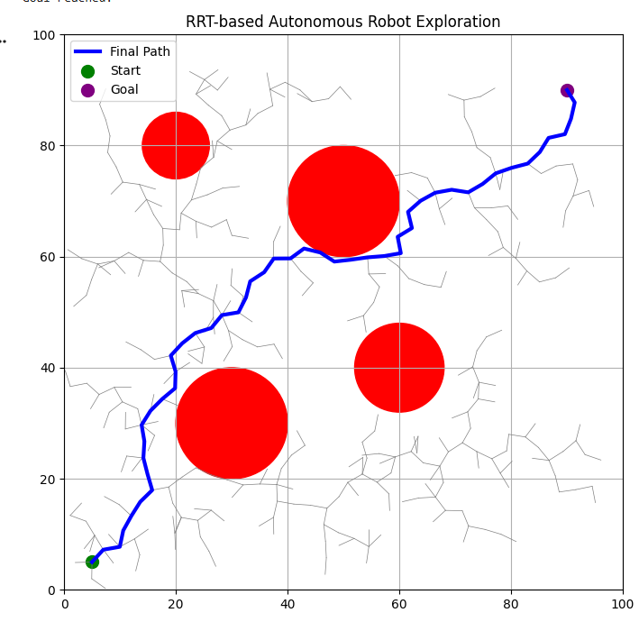

RESULT
The autonomous exploration robot successfully navigates and explores an unknown environment using the RRT sampling-based planning algorithm.
The generated path is collision-free, efficient, and visually demonstrates the robot’s exploration behavior.

